**Capstone Proposal**

Attention-Deficit/Hyperactivity Disorder (ADHD) is a diverse chronic condition affecting nearly five to ten percent of the children population in the world. The disorder often severely impacts social and occupational functioning, as quality of life for those affected. Some of the most common symptoms are hyperactivity, impulsivity, and inattention, which are present during social, academic, or occupational activities.

**Problem Statement**

Children with ADHD may display symptoms of impulsivity and hyperactivity, including talkativeness, restlessness, and a tendency for making impulsive decisions without considering potential consequences.

According to the Centers for Disease Control and Prevention (CDC), approximately 6.1 million children in the United States have been diagnosed with ADHD. Boys are more likely to be diagnosed with ADHD than girls. In the United States, the ratio of boys to girls with ADHD is 3:1.

The average age of ADHD diagnosis is 7 years old and it is treated with medication, behavioral therapy or a combination of both. ADHD impacts daily life and children with ADHD are more likely to struggle in school and have difficulty making and keeping friends. Additionally, the effectiveness of ADHD treatment in reducing the risk of comorbidity has been suggested as a potential area for further investigation.

**Solution**

Create a GenAI system that supports children with ADHD in managing emotional control, time management, and planning and scheduling.

Features:

• Users input their current emotional state e.g. Angry, sad, happy, scared. Time-related challenges, e.g., house chores, homework deadlines, or scheduling issues into the application e.g., therapist appointment, medication refill.

• The WISE.com GenAI system utilizes prompts and questions to gather additional context and relevant details about the child's specific challenges and needs.

• Based on the gathered information, the application WISE.com offers personalized strategies and recommendations to help the child manage their emotions, improve time management, and enhance planning and scheduling skills.

Use Case: For example, a child with ADHD can use the application to input their current emotional state, such as feeling overwhelmed or anxious, and their struggles with time management and scheduling. The GenAI system engages the child in a conversation, asking targeted questions to understand the triggers for their emotions and the specific time-related challenges they are facing. Based on this information, the application provides tailored suggestions and techniques to help the child regain emotional control, improve time management, and enhance planning and scheduling skills. This can empower the child to make informed decisions and take proactive steps to manage their ADHD symptoms effectively.

#### Week 1:

#### Who will benefit from using WISE.AI?

* Children with ADHD
* Parents and caregivers of children with ADHD
* Educators and school counselors
* Behavioral therapists and healthcare providers

#### Why Should You Use WISE.AI?

WISE.AI is an AI tool designed specifically to assist individuals with ADHD by bridging the executive function gap for:

1) Current Emotional State

2) Time Related Challenges

3) Scheduling of day-to-day activities

The tool incorporates positive reinforcement, personalized support, with self-training AI for continual improvement. In future deployment, the Agent can include more categories. For example,

4) Medication Management

5) Weight Loss

6) School Issues

7) ADHD Related Conditions

#### How Should You Use WISE.AI?

Usage of WISE.AI involves accessing the Agent service, engaging with the AI-Agent for ADHD support, utilizing the available services, exploring pricing options, ensuring safety and confidentiality, seeking additional information through FAQs, and accessing customer support as needed.

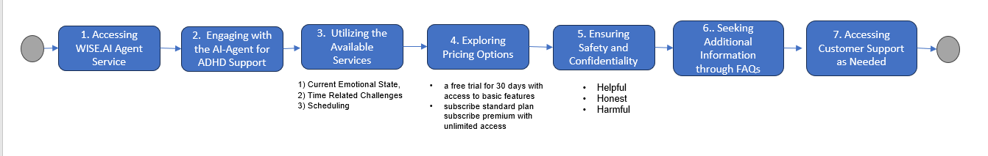

1. Accessing WISE.AI

User can access WISE.AI directly in the website or via a link e.g., WISE.AI

User can sign up for a free trial for 30 days with access to basic features or subscribe to several flexible plan options as a standard plan, premium with unlimited access

1. Engaging with WISE.AI

Users can start a conversation with the AI Agent. It will listen to the user’s questions and provides personalized support based on human’s subject matter experts (SMEs) with experience in Mental Health and Cognitive Behavioural Therapy (CBT) techniques.

1. Services

WISE.AI Agent provides strategies such as chunking, reality check, RGA, problem-solving, and self-efficacy development to help users understand and manage their emotions. Time and scheduling.

1. Safety and Confidentiality

WISE.AI emphasizes safety and confidentiality, ensuring the Helpful, Honest, Harmful principle as apply during the user iteration and improve user experience. It also assures that user sessions are kept confidential.

1. FAQ and Additional Information

WISE.AI provides a section for frequently asked questions, addressing various queries related to the service and have a knowledge Base of more than 100 questions.

1. Customer Support

Users can reach out to customer support via the provided email: [email protected]

#### How do you plan to evaluate the performance of your solution?

Performance will be measured during training by using hyperparameters, metrics and adapting the model overtime with prompts, Retrieval Augmented Generation (RAG) and Fine tuning and Reinforce Learning.

The model is small, has low accuracy, high performance and it is easy to explain, leading to a Knowledge Distillation to mimic a large model, but starting small.

In addition, once the application is deployed into production, it will be evaluated by its reliability, accuracy and have a constant upgrade to allow for a larger model.

**Model Evaluation**

* 1. Accuracy

This metric provides a simple and intuitive measure of the model's overall correctness and is valuable for understanding the proportion of correct predictions. Expectation is that the model has a small data set, or knowledge base set of questions with an estimate of a baseline for accuracy is 70%.

Ideally by applying a machine learning model the accuracy can increase as data increases.

* 1. Precision and Recall

Precision is the ratio of correctly predicted positive observations to the total predicted positives (ranking stage).

1st Launch: Precision: 70%, it can rely on the model, with prompt engineering.

* Preference for Precision: Ensuring the first answers are detailed and create a strong first impression, leading to higher user retention.
  1. Recall

Is the ratio of correctly predicted positive observations to all actual positives (prioritize at retrieval stage, sensitivity).

1st Launch: Recall: 80%, with human validation due to the nature of WISE.AI as part of the healthcare domain.

* Preference for Recall: By recommending a set of strategies for each category,

1) Current Emotional State, 2) Time Related Challenges, 3) Scheduling of day-to-day activities. The platform can gather data on user preferences faster, this could accelerate the user personalization process.

* 1. Confusion Matrix

Summarizes the performance of a model in machine learning.

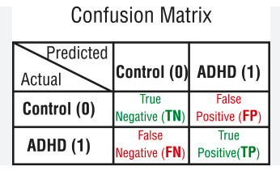

* 1. User Feedback

Gather user feedback through surveys, interviews, and ratings to understand user satisfaction and engagement levels. Monitor the number of active users and the frequency of their interactions with WISE.AI.

* 1. Management of ADHD

Using the categories of 1) Current Emotional State, 2) Time Related Challenges, 3) Scheduling of day-to-day activities, to measure the effectiveness of WISE.AI in helping users complete those activities effectively. Also, evaluate if WISE.AI contributes to a reduction in ADHD symptoms such as emotional outburst, disorganization, and time management difficulties.

* 1. Personalization and Adaptability

Assess the degree of personalization offered by the WISE.AI to tailor its support to individual user needs during customization. Also, measure the ability to adapt to changes in user routines, interruptions, and unexpected events.

* 1. Privacy and Security

Ensure the WISE.AI complies with data privacy regulations and safeguards user data and interactions to protect user information and maintain confidentiality.

* 1. Metrics

Harmless 60%, Honest 90%, Helpful 90% (any suggestions)

**Model Building**

Further, a Knowledge Base was created with at [least 100 questions](https://docs.google.com/spreadsheets/d/1j82be2ibJ7lnf2ONGNeqf0LxBVitZvl2XmiFjCmH44A/edit#gid=111033510) to support the model and check them against a human expert (Psychologist located in Toronto, Canada). The subject matter expert provided a professional point of view from the clinical expertise. (See Appendix A, B, C, D).

The questions and answers were consolidated in a xlsx. file format and then converted into a pdf. to upload into ChatGPT version 3.5 model. A total of 225 Q&A were created:

* Emotional State: 117 Q&A
* Time Related Challenges: 46 Q&A
* Scheduling Issues: 62 Q&A

The Physiologist reviewed 5 questions and answers from the categories listed above. A total of 4 out of 5 responses were considered Helpful with a 90% satisfaction and 1 question was considered to be very Honest with a 90% satisfaction. The feedback received was that the responses to the questions were generally helpful and considerate of the child's needs, providing practical guidance and information to support them in managing their ADHD.

Further research and upgrade of the model is needed to reach a confident state.

**Building a Responsible Product**

|  |  |  |
| --- | --- | --- |
| **Criteria** | **Evaluation Focus** | **Follow-up Questions for Negative Responses** |
| **Helpful** | Effectiveness of the response in solving the user's problem.  •User Success Metrics: Track user success metrics, such as task completion rates, user satisfaction scores, and positive outcomes attributed to the AI agent's assistance.  •User Retention: Measure the retention of users who have received help from the AI agent over time, indicating the perceived value and helpfulness of the AI agent.  •Qualitative Assessments: Conduct qualitative assessments through user interviews and feedback to understand how users perceive the AI agent's helpfulness. | - Is it not solving the specific problem (e.g., information about a emotional control, time management or scheduling).  - Is it too verbose or not to the point?  - Does it miss key information in the response? |
| **Honest** | Accuracy and truthfulness of the response.  •Accuracy of Information: Measure the accuracy of the information provided by the AI agent against verified sources and factual data.  •Transparency: Evaluate the AI agent's transparency in disclosing its limitations, capabilities, and the nature of its interactions with users.  •Ethical Compliance: Ensure that the AI agent adheres to ethical guidelines and refrains from providing misleading or deceptive information. | - Did the model fabricate the answer or provide non-factual information?  - Is the cited source information incorrect or unverifiable?  - Are the cited links or quotes non-existent? |
| **Harmless** | Safety and appropriateness of the response.  •User Feedback: Gather user feedback through surveys, interviews, and reviews to assess if the AI agent's interactions are perceived as harmless by users.  •Incident Reports: Monitor and analyze incident reports related to the AI agent's behavior to identify any potential harmful effects on users.  •Compliance with Guidelines: Ensure that the AI agent complies with ethical guidelines and industry standards to maintain a harmless interaction environment. | - Does the response contain harmful content (hate speech, toxicity, profanity, abuse, sexual or violent content)?  - Does it solicit personal information from the user?  - Does it reveal internal company information or encourage harmful actions?  - Does it share the demerits of the company or its products? |

How do we differentiate from ChatGPT or other applications?

* WISE.AI

WISE.AI is designed to benefit individuals in the great majority, children with ADHD seeking accessible and personalized support, when dealing with 1) Current Emotional State, 2) Time Related Challenges, 3) Scheduling of day-to-day activities. WISE.AI will help by providing emotional support through empathetic and context aware interactions. Using NLP and generative models to help navigate their daily lives and achieve their goals.

It can be used as a complementary tool for individuals seeking professional therapy; while other applications exist in the market and currently in production, those applications target adults with ADHD. Each of these products serves unique purposes and different user needs.

Applications in production:

* Calmify.ai

Focused on providing mental health support, is a self-help tool that provides evidence-based, personalized, and empathetic support for mental health issues such as depression, anxiety, insomnia, relationship issues, low self-esteem, trauma, and major life changes. It employs Cognitive Behavioral Therapy (CBT) strategies to help users understand and manage emotions. The tool is powered by Large Language Models (LLMs) to provide personalized support. Offers flexible pricing plans, including a free version with limited messages, a standard version with unlimited sessions and 150 messages per month, and a premium version with unlimited access and messages.

* Comigo.com

Is tailored to assist individuals with ADHD, is an artificial intelligence tool designed to assist individuals with ADHD. It serves as a companion to bridge the executive function gap experienced by over 300 million adults with ADHD. It facilitates task planning, scheduling, sequencing, and prioritization, and provides focus guarding and single task execution to enhance productivity. Utilizes positive reinforcement and reward mechanics to motivate users and foster a sense of achievement. It provides personalized support, task management features, performance tracking, and continual improvement functionalities.

* ChatGPT

Is a versatile conversational AI model that can engage in various discussions and provide information. It is used to generate responses to prompts, ask questions, and provide information on a wide array of topics. However, it does not have the professional validation of a clinical provider to assess the responses in regards to ADHD.

#### What are the limitations and risks we find?

Deploying a GenAI product for children with ADHD, in the healthcare domain carries significant limitations and risks related to ethical considerations, hallucination for inadequate answers, data privacy and security, bias, and others. These factors must be taken into account and addressed to ensure the responsible and effective use of AI in supporting children with ADHD.

* **Regulatory and Ethical Considerations:** There is a risk of reinforcing negative thinking patterns or dependency, especially in children with ADHD. Ensuring ethical AI practices and safeguarding user data are crucial steps in deployment.
* **Reliability and Hallucinations for Inadequate answers**: The product might not be equipped to handle severe mental health issues such as those experienced by children with ADHD, such as major depression, substance abuse or bipolar disorder. The complexity of ADHD symptoms and treatment may go beyond the capabilities of AI chatbots or Agents. To make the product reliable, applying Grounding as a method to reduce hallucinations will be needed.

Furthermore, constant improvement to support the criteria Helpful, Honest and Harmless (HHH) in the responses provided to reach 95% for each category is recommended.

* **Data Privacy, Guardrails and Security:** As WISE.AI becomes more sophisticated, it may collect sensitive information about users, such as their mental health history, demographic and personal preferences. It is crucial that developers take steps to protect user privacy and ensure that user data is not sold or shared with third parties, especially when it comes to children's sensitive data. It is important to follow the new legislations that govern Healthcare and Artificial Intelligence around the world. For example,

[Pan-Canadian Artificial Intelligence](https://www.blg.com/en/insights/2023/06/the-canadian-legal-landscape-on-ai-enabled-medical-devices)

Artificial Intelligence and Data Act

[WHO regulation of AI in healthcare](https://www.who.int/news/item/19-10-2023-who-outlines-considerations-for-regulation-of-artificial-intelligence-for-health)

[COPPA](https://www.ftc.gov/legal-library/browse/rules/childrens-online-privacy-protection-rule-coppa)

[EU AI Act](https://artificialintelligenceact.eu/#:~:text=What%20is%20the%20EU%20AI,AI%20to%20three%20risk%20categories.)

* **Fairness and Bias:** It is possible that bias is presented in the algorithms used to diagnose and treat mental health conditions, which could lead to unreliable predictions. Special attention must be given to ensuring algorithms are designed and trained with diversity, inclusivity, and fairness in mind.
* **Accountability for transparency**: Establishing clear accountability for the decisions and outcomes of the AI model, especially in the context of healthcare for children with ADHD, presents significant challenges. Assigning responsibility for potential errors or biases in the AI system is essential but complex.

#### When can we launch?

Launch of WISE.AI agent can take approximately 18-36 months, factoring in the complexities of developing a child-friendly, clinically validated, and ethically sound solution for managing ADHD symptoms and supporting emotional well-being. Based on inference the product needs to meet a high level of reliability, accuracy and constant upgrade. For example,

1. Research (3 months)

* Execute research in ADHD for children, have meetings with Subject Matter Experts (SMEs) as child psychologists, doctors, teachers, parents and children. Collect and analyze data to understand the needs and challenges of children with ADHD

2. Concept (3 months)

* Define the core functionality for WISE.AI features, target audience, personas, develop data knowledge based, architecture front end and back end needed. Create detail specs for design, and technical specifications

1. Development (6 months)

* Create a development team with experience in AI, child phycologists, software engineers. Include development capabilities, interactive features, empathy and conversation capabilities. Implement front and back-end solutions. Do testing and debugging

1. Prototyping (3 months)

* Create a prototype version of WISE.AI. Execute user testing to refine usability, with children, parents, educators and therapists. Gather feedback on usability, language, content appropriateness, and overall user experience. Refine based on feedback.

1. Regulatory Compliance and Safety (6 months)

* Ensure compliance with regulations related to child online privacy protection and mental health interventions. Implement safety measures to prevent inappropriate content, safeguard user data, and enable parental control

1. Clinical Validation and Efficacy Testing (8 months)

* Collaborating with ADHD specialists and child psychologists to validate the AI agent's effectiveness in supporting children with ADHD. Conducting trials and gathering data on the WISE.AI impact on ADHD symptoms, emotional regulation, and behavioral outcomes

1. User Engagement and Feedback (4 months)

* Launching beta versions to a select group of users, including children, parents, and educators, in this second round of testing to gather feedback on user experience and effectiveness.

Iterating on the WISE.AI agent's design, content, and features based on user input and behavioral data analysis

1. Marketing and Awareness (4 months)

* Developing marketing materials, educational resources, and communication strategies to raise awareness about the AI agent among parents, educators, and healthcare professionals. Collaborating with ADHD advocacy groups and mental health organizations to promote the AI agent's benefits and accessibility

1. Launch and Post-Launch Support (Ongoing)

* Officially launching WISE.AI agent for public use, accompanied by ongoing monitoring, support, and updates to address user needs and emerging research in ADHD management. Maintain engagement with the user community and stakeholders to ensure WISE.AI remains effective and relevant.

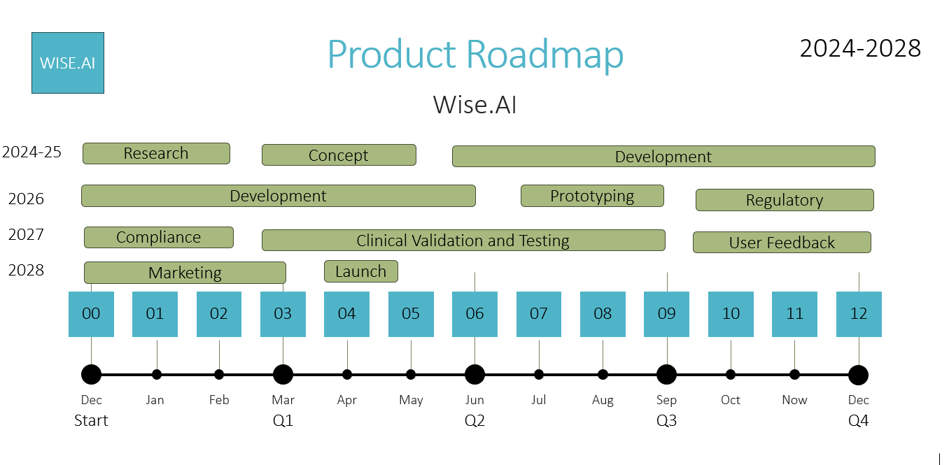

#### What success looks like?

Reduce the burden on children, parents, teachers, and clinicians in dealing with children’s emotional control and providing accurate strategies. For the WISE application, training machine learning models to increase accuracy of the responses. Integrate human and expert knowledge to allow continuous learning of the application. Responsible AI development and launch strategies to ensure guardrails are in place to improveuser experience and reliability.

#### What do we have in scope and out or scope?

|  |  |
| --- | --- |
| In Scope | Out of Scope |
| DevelopmentPersonalize SupportEthical and ComplianceUser Testing and FeedbackSafety and Privacy MeasuresClinical Validation Collaboration | Medical DiagnosisMedical TreatmentEmergency Situations supportReplacement for long term therapyDiagnosis of ADHD or other conditionsInvasive Data Collection |

#### Week 2:

#### How is your system architected, can it scale? Explain with a broader high-level diagram that shows User, data, model, train (if exists), Inference and result back to the user?

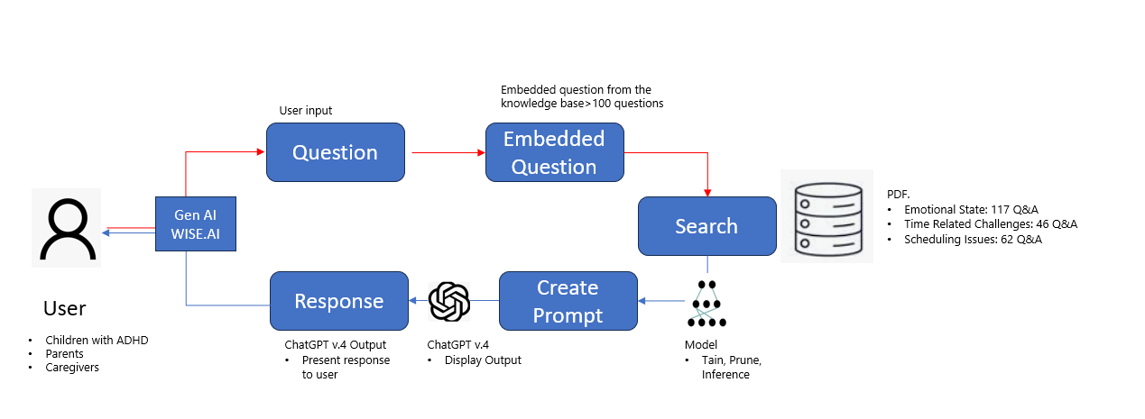

**Architecture**

* **User**

Children with ADHD, Parents, and Caregivers. The primary users who interact with WISE.AI to seek support, guidance, and information related to ADHD management for these categories:

1) Current Emotional State

2) Time Related Challenges

3) Scheduling of day-to-day activities

* **Data**

User input a question that is embedded in the Knowledge Base.

* **Model**

Transformers GPT 3.5 could be used to get the responses and provide conservational support to children with ADHD. Also, this model is designed to understand user input, generate personalized responses, and supports RAG. The model training pipeline ensures that WISE.AI continuously learns from new data, while the real-time inference engine delivers timely and personalized responses to the users.

In addition, Sentiment Analysis Models will support understanding the emotional context of the child's interactions and responses, allowing empathetic responses from WISE.AI

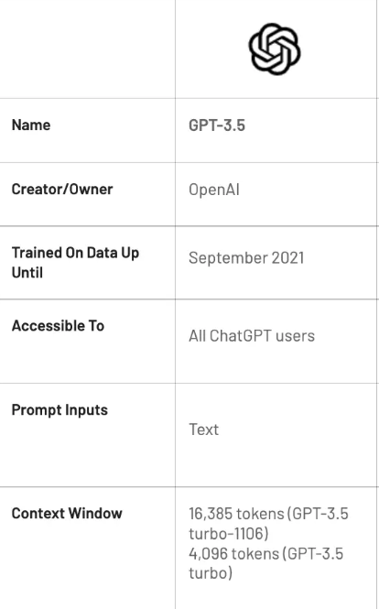

* **Train**

Structured training data, including user interactions, expert responses, and validated ADHD-related content by a Human SME for example a psychologist.

The WISE.AI model will use the latest data and best practices in ADHD management.

* **Inference**

The input will be processed to generate user engagement, emotional state, and behavioral patterns to personalize the interactions with WISE. Chat GPT-4, is used to process user prompts, generate contextually relevant responses, and provide supportive interactions aligned with the unique needs of children with ADHD.

* **Result Back to the User**

The results provided back to the user, tailored recommendations and coping strategies for:

1) Current Emotional State

2) Time Related Challenges

3) Scheduling of day-to-day activities

WISE.AI is an AI tool designed specifically to assist children with ADHD. The architecture should facilitate the delivery of AI-generated responses ensuring that the outputs are presented in a child-friendly and understandable manner.

**Scalability**

* **Fine Tuning**

It is important to use data and expert human feedback to improve the knowledge base (data set) to increase performance, reliability for specific use cases in ADHD. Also, create several models to support additional use cases.

* **Improve customer satisfaction**

During the iteration with WISE.AI, it is important to provide a more supportive and user-friendly experience. could be possible to partner with health care organizations and experts in the field of ADHD to gain insights to support the community.

* **Optimization**

Utilizing small agents can optimize performance and cost, reducing response times, improving accuracy, and decreasing computational resource requirements.

* **Integration**

The architecture should facilitate seamless integration with external APIs, databases, and services to access data, execute actions, and retrieve results, ensuring flexibility and extensibility.

A detailed investigation to the AI stack must be taken in consideration for future escalation.

| AI Stack and ML to build WISE.AI end to end | |
| --- | --- |
| AI Chips | To guarantee good performance and parallel processing for WISE.AI, it is required the use of ChatGPT version 3.5; which uses Nvidia GPU A100. Also, include benchmarks for performance, to revisit if an upgrade is required. Partner with AI Researchers, Developers, Cloud architecture for escalation. |
| API | For future data integration, connections to APIs and specific data end points are relevant to provide the most up to date information, seamless and intuitive interactions to children with ADHD. |
| Custom Coding | Diverse data sources form reliable healthcare organizations, including user input, contextual information, and historical interactions to personalize responses and support children's emotional well-being needs custom coding will be done in Python and to meet the HHH criteria for responsible AI. |
| AI Framework | Use PyTorch to support Python coding and as a dynamic AI framework. PyTorch supports blocks of ML models, availability to modify the model on a fly to do updates, easier to debug, and to experiment with the model. |
| ML Ops | SageMaker by Amazon is the recommended platform to allow developers and data scientists to build, train, and deploy the ML models needed for WISE.AI. Also, it is supported by PyTorch, to execute hyperparameter tuning as LoRa, and distributed training. |
| AI Service | To make the user interactions with WISE.AI more personal, in the future it will be required, a Natural Language Processing and Speech Recognition Service to support the AI Assistance components. The Potential providers are NLP Google Could Platform or Amazon Web Services. |
| AI Product | WISE.AI will used the search provided by ChatGPT version 3.5 to receive AI-generated responses that have been validated by a Human Expert e.g., Psychologist. |

#### 2. How are you making sure you are building responsible AI products?

Source: <https://docs.google.com/document/d/1zm1C6vPPMI3OqzjT2X7SousZGAvqjw-IUAypII7St44/edit#heading=h.4j28tatfm5vk>

**Publish** [**model.card**](https://github.com/meta-llama/llama3/blob/main/MODEL_CARD.md)

|  |  |
| --- | --- |
| **Accountability:** To ensure that your ML system is designed with a positive impact on people, organizations, and society, start by assessing its potential impact during the design or requirement-gathering stage of your product and follow these steps. | |
| What are the efficacy and limitations of your product? | Efficacy: Human validation from Psychologists to validate the responses has been incorporated in the knowledge base. However, it is necessary to work with healthcare providers, hospitals, ADHD groups, access other repositories or databases that have data availability to gather diverse and detailed information to facilitate development and support more efficient responses.  Limitation: Ethical considerations, hallucination for inadequate answers, data privacy and security, bias, and others are known to WISE.AI. Disclaimers can be displayed to inform users that the information displayed may not be 100% accurate, need continuous improvement, potential bias in the data, and necessary human oversight to ensure ethical and effective use. |
| What compliance and Policies apply to manage sensitive data? | Include **Guardrails** to guarantee the safeguard in sensitive user information, including mental health history, demographics and personal preferences. Compliance with healthcare and artificial intelligence legislations, for instance:   * General Data Protection Regulation (GDPR) * Children's Online Privacy Protection Act (COPPA) * Health Insurance Portability and Accountability Act (HIPAA) * Personal Information Protection and Electronic Documents Act (PIPEDA) * Personal Data Protection Act (PDPA) |
| How will you Manage sensitive data? | By following the legislations and policies that provide a framework for managing sensitive data responsibly. Ensuring data privacy, security, and ethical handling of personal information in the development and operation of WISE.AI. Have access to a legal committee for questions to support development and deployment. |
| Human oversight and control? | Professional clinical providers as Phycologist are needed to assess and mitigate the risks and should restrict the use of WISE.AI if there are activities that can cause a risk and restrict the use of the application. |
| **Transparency:** Transparent systems ensure that all stakeholders, including those who use the system to make decisions and those who are impacted by those decisions, can understand how the system is designed, how it functions, and how it can be modified | |
| What are the direct and indirect use cases of your solution? | The direct use case of the WISE.AI GenAI system is to provide personalized strategies and recommendations to help children with ADHD manage their emotions, improve time management, and enhance planning and scheduling skills. The indirect use cases include supporting parents, caregivers, educators, school counselors, behavioral therapists, and healthcare providers in understanding and assisting children with ADHD in their emotional and time-related challenges. |
| How do you come up with results, what is considered on each step? | The results for the WISE.AI GenAI application will be created from gathering input from users regarding their emotional state, time-related challenges, and scheduling issues. The application utilizes prompts and questions to gather additional context and relevant details about the child's specific challenges and needs. Based on the gathered information, the application offers personalized strategies and recommendations to address the identified challenges. Each step involves engaging the user in a conversation, asking targeted questions to understand the triggers for their emotions and the specific time-related challenges they are facing. |
| What benchmarks like accuracy, precision do you need to share? | Benchmarks such as accuracy (70%) , recall (80%) and precision(70%) are essential to share in the context of the WISE.AI GenAI. Accuracy in understanding and addressing the emotional state and time-related challenges of the child, as well as precision and recall in providing tailored suggestions and techniques, are benchmarks to ensure the effectiveness of the application. Also, criteria for (HHH) Harmless, Honest and Helpful in the responses needs to be included for striving for a 95% score in each category is ideal. |
| What disclosure will we need here? | Informing users, including children with ADHD, parents, caregivers, educators, and healthcare providers, about the AI-driven nature of the application. It is important to disclose that the application utilizes AI to provide personalized support and recommendations, ensuring transparency and understanding of the system's capabilities and limitations. Additionally, any data collection and privacy policies should be disclosed to ensure informed usage of the system. |
| **Fairness:** To ensure that your ML/AI systems provide a similar quality of service for all identified areas of operation, including marginalized groups, here are some practical questions to come up with your own policy. | |
| What groups will be underrepresented, i.e., your product will not work for these specific groups? How will you close this gap? (identify minimum data needed and collection plan) | The WISE.AI AI model is designed and trained with a focus on diversity, inclusivity, and fairness to ensure reliable predictions. However, WISE.AI is not optimal for individuals with severe cognitive impairments or those who require specialized, individualized care beyond the scope of the AI tool. E.gAdditional mental health conditions such as bipolarity, schizophrenia, substance abuse etc. To close this gap, it is essential to identify the minimum data needed for these specific groups and develop a plan with healthcare professionals, behavioral therapists, and caregivers to gather insights and data specific to these groups, ensuring that the AI tool can be tailored to their unique needs. |
| Explain why certain groups don't work with your product? | The product might not be equipped to handle severe mental health issues such as those experienced by children with ADHD, such as major depression, substance abuse or bipolar disorder. The complexity of ADHD symptoms and treatment may go beyond the capabilities of AI chatbots or Agents. |
| What test/feedback loop will you put to identify groups that are not working well in your product? How will you address these? | Gather feedback from users, caregivers, and healthcare providers e.g., questionnaires, focus groups, meetings, to assess the effectiveness of the application for specific groups. Addressing these issues may involve refining the WISE.AI capabilities, collaborating with experts to develop specialized interventions, or providing alternative resources and support for groups that may not benefit optimally from the AI tool. |
| **Reliability and safety**: To ensure that your ML/AI features consistently produce reliable and safe results, we need to proactively identify and address any safety-related issues and be transparent with our users about any vulnerabilities. Here are some practical questions that will help you to implement this in the product development lifecycle: | |
| what a reliable and safe product experience entails, what are acceptable error rates? | Providing accurate and personalized support to children with ADHD, ensuring that the recommendations are effective and beneficial. Acceptable error rates should be minimal, particularly in providing emotional support and time-related guidance to the children. |
| What are the consequences of inputting data into your system? What can go wrong here? | The potential for inaccurate recommendations or strategies, which could impact the well-being and progress of the children. Data input errors could lead to the AI tool providing ineffective or unsuitable suggestions, as hallucinations, potentially affecting the emotional state and daily routines of the children. |
| What is the recovery plan in case the system is not working as intended? | If WISE.AI is not working as intended then apply corrective measures to address any issues promptly. This may include refining the AI algorithms, seeking expert input to improve the system's capabilities, and providing alternative support resources for the children as a website, specific consultation with a clinician, including a customer service line with a phone line access. |
| How do you plan to moderate the usage of the system and monitor the health of the system? In case things go wrong, how do you plan to communicate to your customers? | Have regular assessments or audits of the WISE.AI application for performance and impact on the children will be conducted. In case of issues, clear and transparent communication will be essential to inform customers, including children, parents, and healthcare providers, about any problems, the steps being taken to address them, and any alternative support available. |

#### 3. List all cost and accuracy trade-offs you are making and explain why?

The estimated annual cost for WISE.AI could range from approximately $1,810,000 to $3,080,000. These numbers below are approximate and can vary based on specific project requirements and other factors.

|  |  |
| --- | --- |
| Category and cost per year | Accuracy Trade-Offs |
| Team-SME Clinical: $80,000-120,000-Tech: $1000,000-$150,000-Data Scientist: $120,000-$180,000-PM: $1000,000-$150,000 | Clinical Validation vs. Time to Market:• Rigorous clinical validation and testing can delay the time to market, impacting the speed of delivering WISE.AI to users. Clinical validation is essential for ensuring the effectiveness of the AI agent, there is a trade-off with the time required to bring the product to market. |
| Product-Research: $50,000 - $80,000-Concept: $30,000 - $50,000-Development: $150,000 - $250,000-Prototyping: $50,000 - $100,000-Regulatory and Compliance: $80,000 - $120,000-Clinical Validation and Testing: $100,000 - $150,000-User Feedback: $30,000 - $50,000-Marketing: $100,000 - $200,000-Launch: $50,000 - $100,000 | • By using a smaller model, it can be less complex, and can reduce inference time and computational costs, making WISE.AI more responsive and cost-effective, but it can cause a trade-off in accuracy.In addition, the model needs to be updated regularly to make sure it is effective and relevant. For instance, every two months to incorporate the most recent clinical research findings and technology upgrades. |
| AI Stack-AI Chips: $200,000 - $300,000-Custom Coding: $100,000 - $150,000-AI Framework: $50,000 - $80,000-ML-Ops: $80,000 - $120,000-AI Service: $150,000 - $250,000 | •Prioritizing safety measures, including content moderation and age-appropriate responses, is essential for protecting children. However, this may impact real-time responsiveness, as additional checks and filters are applied to ensure the appropriateness of the AI agent's interactions. As a result, implementing extensive safety measures and content moderation can impact the real-time responsiveness of WISE.AI, so it could be a delay in responses. |

#### Week 3:

#### Question: Create a Roadmap with MVP to first Pilot with impact?

Phase 1: Research and Conceptualization (2-4 months)

* Conduct extensive research on ADHD, child psychology, and existing AI-based interventions. Define functionality, features, and target user experience through consultations with child psychologists, educators, and ADHD experts.
* Risk: Not having enough professionals to provide input. Potential ethical concerns and bias. Meet regulatory compliance with child only privacy and mental health regulations.

Phase 2: MVP Development (6-9 months)

* Design and develop the Minimum Viable Product (MVP) of WISE focusing on core conversational capabilities and context-aware support for children with ADHD. Implement initial safety measures, content moderation, and privacy features to ensure a safe and supportive user experience.
* Risks: Display inappropriate content, causing harm to children's mental well-being if not addressed effectively. It is possible that WISE.AI does not add clinical value in supporting children with ADHD, causing unhappy customers.

Phase 3: User Testing and Feedback (2-4 months)

* Launch the MVP to a select group of users for example 100 users, including children, parents, and educators, to gather feedback on user experience and effectiveness. Iteratively improve the MVP based on user input and behavioral data analysis to enhance engagement and impact.
* Risks: low user acceptance and trust if the AI agent fails to provide accurate and empathetic support, impacting the credibility and success of the product.

Phase 4: Clinical Validation and Collaboration (6-12 months)

* Collaborate with ADHD specialists and child psychiatrists to validate the MVP's efficacy in supporting children with ADHD and addressing emotional and behavioral challenges. Conduct controlled trials and gather data on the MVP's impact on ADHD symptoms, emotional regulation, and behavioral outcomes.
* Risks: Ensuring ethical AI practices and safeguarding user data are crucial steps in deployment. Reliability and Hallucinations for Inadequate answers be addressed.

Phase 5: Pilot Deployment (3-6 months)

* Deploy the validated MVP as a pilot program in collaboration with healthcare facilities, schools, and mental health organizations to assess its real-world impact. Gather insights for further improvements. Assess the impact of the pilot program, gathering qualitative and quantitative data on its effectiveness and user satisfaction.
* Risks: Compliance with child online privacy protection regulations and mental health intervention standards, which could lead to legal and reputational consequences if not adhered to.

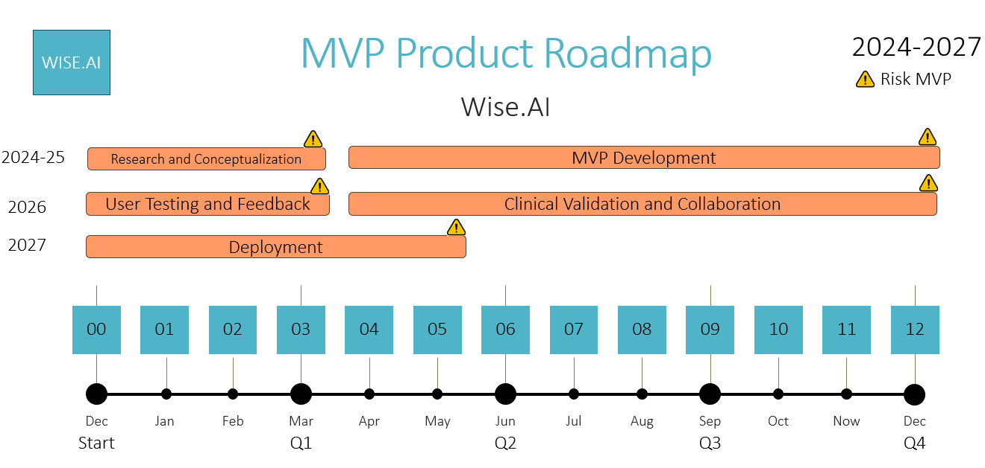

**Appendix**

#### Benchmark Data for Testing the Knowledge Base: WISE.AI Questions. PDF

A separate document exists in Excel with more than 100 questions and answers.

|  |  |  |
| --- | --- | --- |
| **#** | **Questions Prompt** | **Grounded Answers** |
| 1 | Behaviors do challenge kids exhibit when they don’t have the skills to respond adaptively to certain demands | whining, pouting, sulking, withdrawing, crying, screaming, swearing, hitting, spitting, kicking, throwing, lying, stealing,  and so forth. |
| 2 | Use of a Feelings Thermometer | The Feelings Thermometer shows you when your emotional temperature is getting warmer and then hotter, to potentially dangerous degrees. It starts at blue – the calm zone, and goes to red – the furious zone. Throughout the zones it lists activities to fe​el less angry, frustrated, anxious, and sad. in the classroom, at home, or in the therapy office. I would recommend not just using your thermometer when your kiddo has escalated but also take some time and talk about how it feels to be in the green (happy) zone. |
| 3 | Effective coping skills for children with ADHD to manage their emotions | Effective coping skills include deep breathing exercises, mindfulness techniques, taking breaks, and engaging in physical activity |
| 4 | Common signs of anxiety in children | Common signs of anxiety in children may include excessive worry, fearfulness, difficulty sleeping, irritability, physical complaints like headaches or stomach aches, and avoidance of certain situations or activities. |
| 5 | Parents can do to help kids with ADHD adjust to the school year | Talk to teachers about your child's ADHD and develop a plan together. If your child takes medication, make sure they start taking it again before school starts. Let your child know that the past is a clean slate and focus on moving forward. Develop a plan to address any anxieties your child may have. |
| 6 | ADHD Affect Your Time Perception | Double your time, set the timer for how long you plan to work, Pomodoro Technique |
| 7 | Assistive technologies that can help kids with ADHD | Recording apps with dictation functions, white noise generators, timers |
| 8 | Teach a child to set goals | Using a rock, pebble, and water analogy. Rocks represent essential tasks, pebbles represent extracurricular activities, and water represents leisure activities. |
| 9 | Core symptoms of ADHD | inattention, hyperactivity, and impulsivity. |
| 10 | Side effects of ADHD medication | Headaches, difficulty sleeping, irritability, appetite loss, and jitters. Decreased appetite, weight loss, sleep problems, irritability, and stomach upset. |

#### Using Prompts

**Description:** Support and Guidance for children with ADHD

**Instructions Provided:** As a child with ADHD, look for guidance and support.

Identify the following items from the review document:

-Question 8: Set Goals

-Question 2: Using the Feelings Thermometer

-Question 10: Side effects of ADHD medication

-Question 4: Common signs of anxiety in children

-Question 3: Coping skills for children with ADHD to manage their emotions

**Knowledge Base:** Upload PDF in ChatGPT

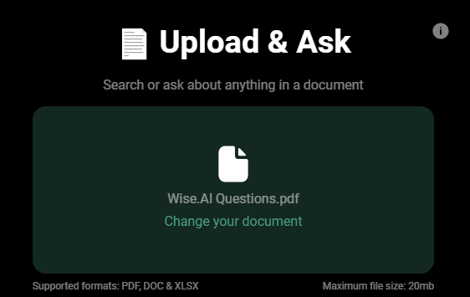

**Prompts**

| **#** | **Item** | **INPUT** | **Type** |
| --- | --- | --- | --- |
| 8 | Set Goals | As a child with ADHD how can I set up goals | Instructions |
| 2 | Using the Feelings Thermometer | You are a child with adhd, now how can you use the feelings thermometer | Role |
| 10 | Side effects of ADHD medication | Referencing the attached document, create a table listing the side effects of ADHD medication, the column headers are medication type, Side effects. answer as a child | Instructions |
| 4 | Common signs of anxiety in children | From the document attached, create a narrative for a child explaining how to identify the signs of anxiety in a child with adhd | Narrative |
| 3 | Coping skills for children with ADHD to manage their emotions Coping skills for children with ADHD to manage their emotions | extract the Effective coping skills for children with ADHD to manage their emotions, list those and provide a maximum of 10 results |  |

#### Using ChatGPT to generate Prompts

ChatGPT version 3.5 architecture was used to provide questions and receive responses, the model was created to engage in a conversational manner to elicit specific information or guidance to support the WISE.AI application.

Prompting ChatGPT with the knowledge base list of questions provides a structured inquiry, guiding it to ask for specific details from the user or to seek clarification on certain ADHD questions. By providing clear prompts and follow-up questions.

Once prompted, ChatGPT can generate relevant questions to gather necessary information from the user and respond to the input received. This model can be leveraged to gather insights, seek advice, or obtain information on a wide range of ADHD topics. By structuring the conversation effectively, users can elicit coherent responses from ChatGPT, enabling them to engage in meaningful and informative exchanges.

The table below list the questions and the two answers provided from Chat GPT in two different dates:

* May 31, 2024
* June 5, 2024

| **Prompt (INPUT)** | **Result (OUTPUT)** | **Expected** |
| --- | --- | --- |
|  |  | Using a rock, pebble, and water analogy. Rocks represent essential tasks, pebbles represent extracurricular activities, and water represents leisure activities.  **Note:** I did not see these specific words. I will give it a 70% accuracy |
|  |  | The Feelings Thermometer shows you when your emotional temperature is getting warmer and then hotter, to potentially dangerous degrees. It starts at blue – the calm zone, and goes to red – the furious zone. Throughout the zones it lists activities to fe​el less angry, frustrated, anxious, and sad. in the classroom, at home, or in the therapy office. I would recommend not just using your thermometer when your kiddo has escalated but also take some time and talk about how it feels to be in the green (happy) zone.  **Note: Very good response. 100% Accuracy** |
|  |  | Headaches, difficulty sleeping, irritability, appetite loss, and jitters. Decreased appetite, weight loss, sleep problems, irritability, and stomach upset.  **Note: Very good response, but table formatting is strange. 90% Accuracy** |
|  |  | Common signs of anxiety in children may include excessive worry, fearfulness, difficulty sleeping, irritability, physical complaints like headaches or stomach aches, and avoidance of certain situations or activities.  **Note: Very good response. 100% Accuracy** |
|  |  | Effective coping skills include deep breathing exercises, mindfulness techniques, taking breaks, and engaging in physical activity.  **Note: Very good response. 100% Accuracy** |

**Benchmark Data for testing “ADHDKnowledgeBaseParentsCaregivers.docx”**

|  |  |
| --- | --- |
| **Question Prompts** | **Grounded Answers** |
| U.S. federal law that ensures services to children with disabilities throughout the nation. | Individuals with Disabilities Education Act (IDEA) |
| Document that is developed for each public school child who needs special education. | IEP (Individualized Education Plan) |
| A plan developed to ensure that a child who has a disability identified under the law and is attending an elementary or secondary educational institution receives accommodations that will ensure their academic success and access to the learning environment. | 504 Plan |
| An Effective behavioral strategy of psychological treatment for children with ADHD | Cognitive Behavioral Therapy (CBT) |
| Dietary supplements or nutrients for brain health | Omega-3 fatty acids, flax seeds, zinc, magnesium, iron supplements |
| Strategies helpful for Impulse control | Mindfulness exercises, puzzles or building models |
| herbal supplements | Ginkgo biloba and ginseng |
| Activity used as a stress-relief exercise. | Yoga |
| Non-stimulant medication for ADHD. | Atomoxetine |
| category of ADHD medications | Stimulants |
| Types of stimulant medications | Methylphenidate, Amphetamines |
| Medical condition coexisting with ADHD. | ODD (Oppositional Defiant Disorder) |
| organization that provides support for individuals with ADHD and their families. | CHADD (Children and Adults with Attention-Deficit/Hyperactivity Disorder) |
| strategies to manage emotions and reactions | Deep breathing, mindfulness |

**Description**: Support and guidance for the Parent of kids who have ADHD disorder

**Instructions Provided:**

Imagine yourself as Parent of kid with ADHD disorder looking for guidance and support.

Identify the following items from the review document:

-general category ADHD medications

-herbal supplements

-Stimulant medications

-Name of a medical condition coexisting with ADHD

-Non-stimulant medication for ADHD

-organization that provides support for individuals with ADHD and their families.

-nutrients for brain health

-suggested stress relief exercise

-impulse control strategies

-emotion management strategies

-Effective behavioral strategy of psychological treatment for children with ADHD

-Federal Act designed to protect the rights of individuals with disabilities in programs

-Section Plan number of the rehabilitation act

-Document Name for Special Needs Kid

Format your response as JSON object with "General ADHD Medications", "herbal supplements", "non-stimulant medications", "coexisting condition", "ADHD Support Organization Name", "Necessary ADHD deficient Nutrients", "Stress-Relief exercises", "Impulse Control Strategies", "Impulse Control Strategies", "Behavioral Strategies", "Stimulant Medications", "Federal Act for Disabilities", "Section Plan Number", "Document Name" as the keys.

If the information is not present, use "unknown" as the value.

Make your response as short as possible.

**Conversation starters:**

As a parent of an ADHD kid, extract key information for the question asked.

**Prompt1:**

Imagine yourself as Parent of kid with ADHD disorder looking for guidance and support. Identify the following items from the review document:

-herbal supplements

-Stimulant medications

**Response:**

**{**

**"herbal supplements": "Herbal supplements like ginkgo biloba and ginseng have been explored for ADHD, but it is recommended to consult with a healthcare provider before starting any new supplement regimen.",**

**"Stimulant Medications": "Stimulant medications like methylphenidate and amphetamines increase dopamine and norepinephrine levels in the brain, helping improve concentration and decrease impulsivity and hyperactivity."**

**}**

**Prompt2:**

Imagine yourself as Parent of kid with ADHD disorder looking for guidance and support. Identify the following items from the review document:

-herbal supplements

-Stimulant medications

-Name of a medical condition coexisting with ADHD

-Non-stimulant medication for ADHD

**Response**:

**{**

**"herbal supplements": ["ginkgo biloba", "ginseng"],**

**"stimulant medications": ["methylphenidate", "amphetamines"],**

**"coexisting condition": ["anxiety disorders", "depression", "learning disabilities", "oppositional defiant disorder (ODD)"],**

**"non-stimulant medications": ["atomoxetine"]**

**}**

**Prompt3:**

Imagine yourself as Parent of kid with ADHD disorder looking for guidance and support. Identify the following items from the review document:

-herbal supplements

-Stimulant medications

-Name of a medical condition coexisting with ADHD

-Non-stimulant medication for ADHD

-organization that provides support for individuals with ADHD and their families.

-nutrients for brain health

**Response:**

**{**

**"herbal supplements": "ginkgo biloba, ginseng",**

**"Stimulant Medications": "methylphenidate, amphetamines",**

**"coexisting condition": "anxiety disorders, depression, learning disabilities, oppositional defiant disorder (ODD)",**

**"Non-stimulant Medications": "atomoxetine",**

**"ADHD Support Organization Name": "CHADD (Children and Adults with Attention-Deficit/Hyperactivity Disorder), ADHD Foundation",**

**"Necessary ADHD Deficient Nutrients": "omega-3 fatty acids, zinc, magnesium, iron"**

**}**

**Prompt4**:

Imagine yourself as Parent of kid with ADHD disorder looking for guidance and support. Identify the following items from the review document:

-general category ADHD medications

-herbal supplements

-Stimulant medications

-Name of a medical condition coexisting with ADHD

-Non-stimulant medication for ADHD

-organization that provides support for individuals with ADHD and their families.

-nutrients for brain health

-suggested stress relief exercise

-impulse control strategies

-emotion management strategies

**Response:**

**{**

**"General ADHD Medications": "stimulants and non-stimulants",**

**"herbal supplements": "ginkgo biloba and ginseng",**

**"non-stimulant medications": "atomoxetine",**

**"coexisting condition": "anxiety disorders, depression, learning disabilities, oppositional defiant disorder (ODD)",**

**"ADHD Support Organization Name": "CHADD (Children and Adults with Attention-Deficit/Hyperactivity Disorder)",**

**"Necessary ADHD deficient Nutrients": "omega-3 fatty acids, zinc, magnesium, iron",**

**"Stress-Relief exercises": "physical activities like sports or playing outside, creative activities like drawing or music, mindfulness exercises like yoga or guided breathing",**

**"Impulse Control Strategies": "deep breaths or count to ten, clear rules and consequences, mindfulness exercises, activities requiring patience",**

**"Emotion Management Strategies": "recognize and name emotions, coping mechanisms like deep breathing, taking a break, expressing feelings through words or art, consistent routines and structured activities",**

**"Stimulant Medications": "methylphenidate and amphetamines"**

**}**

**Sources:**

* **​​**
* **​​**
* **​​**
* **​​**
* **​​**
* **​​**
* **​​**
* **​​**
* **​​**
* **​​**

**Prompt5**:

Imagine yourself as Parent of kid with ADHD disorder looking for guidance and support. Identify the following items from the review document.

-general category ADHD medications

-herbal supplements

-Stimulant medications

-Name of a medical condition coexisting with ADHD

-Non-stimulant medication for ADHD

-organization that provides support for individuals with ADHD and their families.

-nutrients for brain health

-suggested stress relief exercise

-impulse control strategies

-emotion management strategies

-Effective behavioral strategy of psychological treatment for children with ADHD

-Federal Act designed to protect the rights of individuals with disabilities in programs.

Make your response as short as possible.

**Response:**

**{**

**"General ADHD Medications": "Stimulants and non-stimulants",**

**"herbal supplements": "Ginkgo biloba, ginseng",**

**"Stimulant Medications": "Methylphenidate, amphetamines",**

**"coexisting condition": "Anxiety disorders, depression, learning disabilities, oppositional defiant disorder (ODD)",**

**"Non-stimulant medications": "Atomoxetine",**

**"ADHD Support Organization Name": "CHADD (Children and Adults with Attention-Deficit/Hyperactivity Disorder), ADHD Foundation",**

**"Necessary ADHD deficient Nutrients": "Omega-3 fatty acids, zinc, magnesium, iron",**

**"Stress-Relief exercises": "Yoga, guided breathing",**

**"Impulse Control Strategies": "Deep breaths, count to ten, clear rules and consequences, mindfulness exercises",**

**"Emotion Management Strategies": "Recognize emotions, coping mechanisms like deep breathing, expressing feelings through words or art",**

**"Behavioral Strategies": "Positive reinforcement, setting clear expectations, consistent consequences, Cognitive Behavioral Therapy (CBT)",**

**"Federal Act for Disabilities": "Section 504 of the Rehabilitation Act, Individuals with Disabilities Education Act (IDEA)"**

**}**

**Prompt6:**

Imagine yourself as Parent of kid with ADHD disorder looking for guidance and support. Identify the following items from the review document:

-general category ADHD medications

-herbal supplements

-Stimulant medications

-Name of a medical condition coexisting with ADHD

-Non-stimulant medication for ADHD

-organization that provides support for individuals with ADHD and their families.

-nutrients for brain health

-suggested stress relief exercise

-impulse control strategies

-emotion management strategies

-Effective behavioral strategy of psychological treatment for children with ADHD

-Federal Act designed to protect the rights of individuals with disabilities in programs

-Section Plan number of the rehabilitation act

**Response:**

**{**

**"General ADHD Medications": "Stimulants and Non-stimulants",**

**"herbal supplements": "ginkgo biloba and ginseng",**

**"Stimulant Medications": "methylphenidate and amphetamines",**

**"coexisting condition": "anxiety disorders, depression, learning disabilities, oppositional defiant disorder (ODD)",**

**"Non-stimulant Medications": "atomoxetine",**

**"ADHD Support Organization Name": "CHADD (Children and Adults with Attention-Deficit/Hyperactivity Disorder)",**

**"Necessary ADHD deficient Nutrients": "omega-3 fatty acids, zinc, magnesium, iron",**

**"Stress-Relief Exercises": "sports, playing outside, drawing, music, yoga, guided breathing",**

**"Impulse Control Strategies": "deep breaths, count to ten, clear rules and consequences, mindfulness exercises, puzzles, building models",**

**"Emotion Management Strategies": "naming emotions, deep breathing, taking a break, expressing feelings through words or art, consistent routines, structured activities",**

**"Behavioral Strategies": "Positive reinforcement, clear expectations, consistent consequences, Cognitive Behavioral Therapy (CBT)",**

**"Federal Act for Disabilities": "Individuals with Disabilities Education Act (IDEA)",**

**"Section Plan Number": "Section 504"**

**}**

**Prompt7:**

Imagine yourself as Parent of kid with ADHD disorder looking for guidance and support. Identify the following items from the review document:

-general category ADHD medications

-herbal supplements

-Stimulant medications

-Name of a medical condition coexisting with ADHD

-Non-stimulant medication for ADHD

-organization that provides support for individuals with ADHD and their families.

-nutrients for brain health

-suggested stress relief exercise

-impulse control strategies

-emotion management strategies

-Effective behavioral strategy of psychological treatment for children with ADHD

-Federal Act designed to protect the rights of individuals with disabilities in programs

-Section Plan number of the rehabilitation act

-Document Name for Special Needs Kid

**Response:**

**{**

**"General ADHD Medications": "Stimulants and Non-stimulants",**

**"herbal supplements": ["ginkgo biloba", "ginseng"],**

**"Stimulant Medications": ["methylphenidate", "amphetamines"],**

**"coexisting condition": ["anxiety disorders", "depression", "learning disabilities", "oppositional defiant disorder (ODD)"],**

**"Non-stimulant Medications": ["atomoxetine"],**

**"ADHD Support Organization Name": ["CHADD (Children and Adults with Attention-Deficit/Hyperactivity Disorder)", "ADHD Foundation"],**

**"Necessary ADHD deficient Nutrients": ["omega-3 fatty acids", "zinc", "magnesium", "iron"],**

**"Stress-Relief exercises": ["yoga", "guided breathing"],**

**"Impulse Control Strategies": ["deep breaths", "count to ten", "mindfulness exercises", "puzzles", "building models"],**

**"Emotion Management Strategies": ["naming and discussing emotions", "deep breathing", "taking a break", "expressing feelings through words or art"],**

**"Behavioral Strategies": ["Cognitive Behavioral Therapy (CBT)", "positive reinforcement", "setting clear expectations and consistent consequences"],**

**"Federal Act for Disabilities": "Individuals with Disabilities Education Act (IDEA)",**

**"Section Plan Number": "Section 504",**

**"Document Name": "Individualized Education Plan (IEP)"**

**}**

#### Human Validation (Phycologist)

The questions from the knowledge base and the responses provided from ChatGPT were sent to a Phycologist, located in Toronto on Jun. 13, 2024 for a general review and input, to assess if the model meets the criteria for Harmless, Honest and Helpful.

**Description:** Support and Guidance for children with ADHD

**Instructions Provided: Review the answers provided by ChatGPT to the questions asked acting** As a child with ADHD, looking for guidance and support.

Identify the following items from the review document:

-Question 8: Set Goals

-Question 2: Using the Feelings Thermometer

-Question 10: Side effects of ADHD medication

-Question 4: Common signs of anxiety in children

-Question 3: Coping skills for children with ADHD to manage their emotions

|  |
| --- |
| **As a child with adhd how can I set up goals?** |
| The response provides practical and age-appropriate steps to help the child set up goals, emphasizing the importance of starting small, being specific, writing down goals, setting deadlines, making a plan, staying flexible, asking for help, and rewarding oneself  The answer is **Helpful** |
| **You are a child with adhd how can you use the feelings thermometer?** |
| The response explains how to use the Feelings Thermometer to understand and manage emotions, breaking down the process into identifying feelings, recognizing signs, using coping strategies, and practicing regularly.  The answer is **Helpful** |
| **Create a table listing the side effects of adhd medication the column headers are medication type, side effects, answer as a child.** |
| The table lists common side effects of ADHD medication, informing the child about potential effects of different medication types.  The answer is **Honest** |
| **Narrative for a Child Explaining How to Identify the Signs of Anxiety in a Child with ADHD** |
| The narrative explains the signs of anxiety in a child with ADHD in a relatable and understandable manner, encouraging the child to seek help from trusted adults if they notice these signs.  The answer is **Helpful** |
| **Extract the effective coping skills for children from children with adhd to manage their emotions list those and provide a maximum of 10 results**  The response provides a list of effective coping skills for children with ADHD to manage their emotions, including deep breathing, physical activity, mindfulness, creative outlets, structured routine, breaking tasks into smaller steps, positive self-talk, taking breaks, using timers, and seeking support 1.  The answer is **Helpful** |
| In conclusion, the responses to the questions are generally helpful and considerate of the child's needs, providing practical guidance and information to support them in managing their ADHD. |

#### RAG Validation using the ChatGPT Playground

#### Chat model v. 3.5

|  |  |
| --- | --- |
|  |  |
|  |  |
|  |  |
|  |  |
|  |  |

#### Prototype UI

[Using Designed](https://app.uizard.io/prototypes/QOAPKAG698HrmQvelJgb) the following prototype was created to mimic the landing page of the WISE.AI application.

Description: Empower ADHD kids with WISE.AI: Personalized support for emotional regulation, time management challenges and organizing daily tasks.

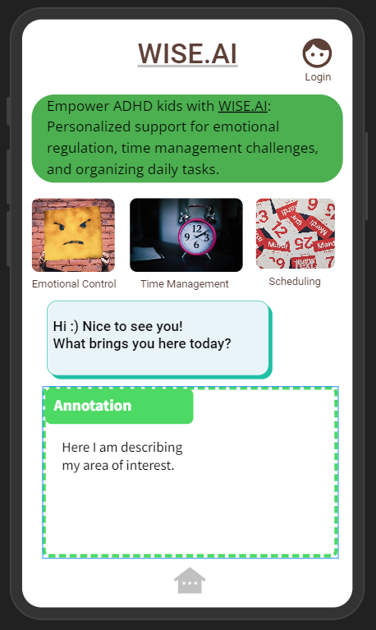

#### Sources

<https://docs.google.com/document/d/1Opzj3aQK6VK4586YAVIaHGt4ryMflsFBlBLvXdLm1Y/edit#heading=h.dx6dw872y3gs>

<https://www.taskade.com/blog/ways-ai-can-help-manage-adhd/>  
<https://genai.works/applications/comigo>

https://www.calmify.ai/

<https://app.orca1di.com/login/index.html>

<https://www.additudemag.com/chatgpt-ai-adhd-executive-function-support/>

<https://www.goldenstepsaba.com/resources/adhd-statistics>

<https://datasets.simula.no/hyperaktiv/>

https://app.roadmunk.com/